DEFENDANT’S SUMMARY OF NIGHT OF SEPTEMBER 6, 2023

NB Trooper Ernstsen is referred to Corporal Ernstsen

Abstract: On the night of September 6, 2023, Utah Highway Patrol Cpl. Brock Ernstsen (CE) was idling approximately 100 feet outside the entrance of Aces High (a bar on 1588 south State St.) when he saw the defendant, Peter Golub (PG), pull from the curb into the middle lane. PG was arrested on a failure to signal and DUI charge. The defense respectfully requests a motion to suppress the evidence on the following grounds: I) the reasons for the arrest are contradicted by the video evidence: CE did not have line of sight on PG’s vehicle as PG pulled from the curb, thus CE could not have known that PG was or was not using his signal. In the video evidence, PG is seen crossing into the middle lane—the signal seems to still be blinking; II) the Affidavit of Probable Cause authored by CE has multiple misrepresentations (e.g. claim that PG refused a breath test); III) the Dui Report Form authored by CE has at least five statements contradicted by the video evidence: i) claim that there was only one arresting officer; ii) claim that CE could see that PG did not have his blinker on when pulling from the curb; iii) claim that PG refused the Preliminary Breath Test; iv) claim that CE performed the search alone; and v) claim that there was nothing wrong with the chemical test and that it took 00:33 seconds (video shows 140 seconds). In addition, CE did not read PG his Miranda Rights until PG was in the parking lot of the jail, at which point the only questions PG is asked pertain to place of residence and income. Moreover, there is a circumstantial argument for bias, as CE is renowned as a trooper who focuses on staking out bars and sporting events to make DUI arrests. Based on articles that quote CE and state statistics, there is a high likelihood, that the stop CE made was not “routine” and made with bias and prejudice. Due to confirmation bias, CE is not a fair and impartial executioner of the scientific and legal procedures of conducting this DUI investigation, which includes his administration of the HGN test and the Nine-Step test, as well as the process of providing an accurate record of the events. Thus, the defense requests that the evidence gathered by CE be suppressed and, on this basis, the case of PG vs. THE STATE OF UTAH be dismissed on the grounds of false pretenses, lack of sufficient probable cause, and most importantly the failure of Utah Highway Patrol Cpl. Brock Ernstsen to report the facts of his arrest and investigation.

- USING 4TH AMENDMENT TO ARGUE that Cpl. Ernstsen lacked probable cause to conduct DUI investigation as Mr. Golub had not broken any traffic laws, and despite the officer’s biased interpretation of the indicators, was in fact not intoxicated. Use this article and anything else that’s useful about 4th amendment arguments used in DUIs to argue that Cpl. Ernstsen did not have the right to arrest Mr. Golub.

- BASE RATE FALLACY

Base rate argument: Please apply the idea of the base rate as described in this text which describes a dog named merlin finding people who are carrying drugs on a plan. I want you to make an analoguous argument, but in this case Merlin will be Cpl. Ernstsen and Mr. Golub will be Smithers i.e. merlin : ernstsen :: golub : smithers. Knowing everything we know about the case, use the same logic to argue for the conclusion that bc Cpl. Ernstsen has such a high stop-to-arrest ratio, he’s statistically likely to make mistakes and arrest innocent people (perhaps even more so than other officers). Because of his confirmation bias, he was unable to adequately judge the situation for what it was, and made the arrest. However, based on logic and statistics, some people are bound to be innocent. If you can find/cite any statistics about police mistakes and false accusations in general, please use them in your argument. Show that states/police departments with arrest rates much lower than Cpl. Ernstsen’s, must still annually withdraw false charges against many people involving serious crimes. And just as Cpl. Ernstsen admits that some people can struggle with a field sobriety test can blow below, the defense should have argued that 1) Cpl. Ernstsen himself admits that Mr. Golub’s driving was perfectly normal, and Mr. Golub did perform adequately on the field tests, showing dexterity, control, and awareness; 2) Whatever indicators he showed can be reasonably explained by fatigue, stress, and medication; 3) Therefore, Mr. Golub was safe to drive.

Quote Utah law that says it is not illegal to drink and drive if below the legal limit, but to driver recklessly while under the influence. Mr. Golub was not driving recklessly. The only piece of evidence again Mr. Golub is the Intoxylizer 8000 test, which the defense should have had suppressed based on problems with the reliability of the machine and administration of the procedure.

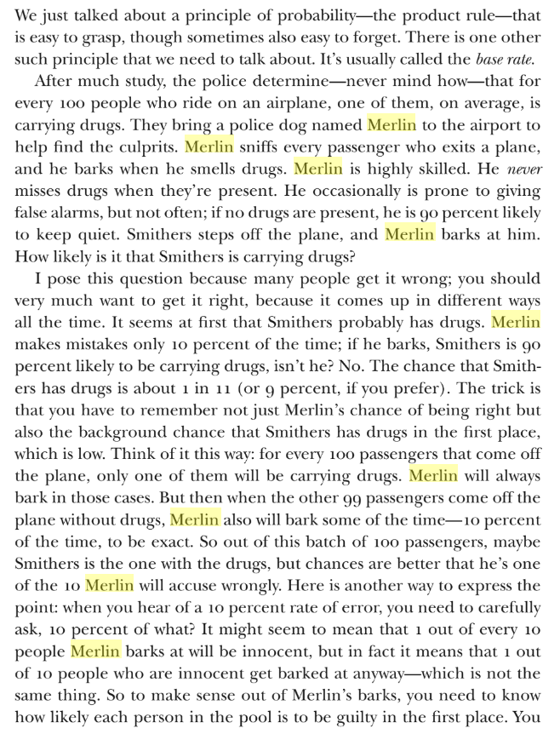
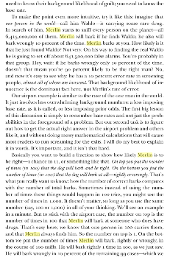
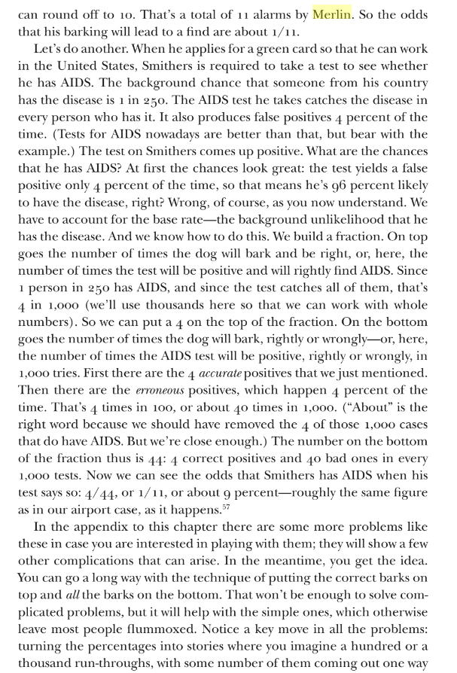
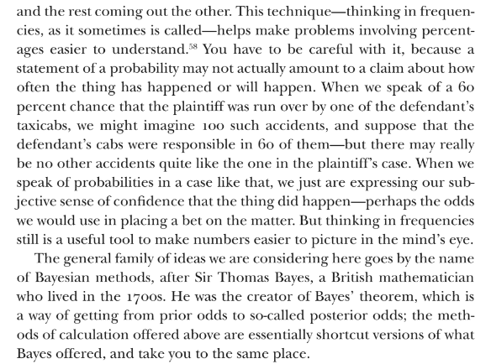

- Argument against Intoxylizer 8000. By referencing these articles and whatever else you can find online, please make a succinct convincing case that the Intoxilyzer machine is unreliable, having been shown to show either impossible or suspiciously high results, especially when administered improperly. Mr. Golub was forced to continuously blow into the machine for nearly two minutes when the accepted maximum is (enter what a reasonable max is). Other than the indicators and clues, which the defense should have shown to be inconclusive/problematic/etc. at best, the Intoxylizer 8000 is the only piece of evidence in the case against Mr. Golub. Given problems with the machine and the administration of the test, counsel should have asked for this evidence to be suppressed and for the case to be dismissed.

- ARGUMENTS AGAINST INTOXYLIZER 8000.

There is something wrong with the machine, and this process. Something needs to be done. I’m not just diong this for me, I want the system to change. It’s already happened to me once (pulled over on false pretense). I know people who peronally say the blew below on the PBT but got arrested anyway, and then somehow after being detained, they blew over on the Intoxylizer, which seems counter intuitive. Many places are getting rid of these machines.

There has been a lot of cost saving on the training and equipment level, while officer salaries keep going up (e.g. Cpl. Ernstsen’s salary is well over 150 k (give example of other professions who make that much money). However, the department has reduced the requirements for training to cost save: the state budget: The proposed changes will clean-up some grammar in the rule, and it also changes the requirement for law enforcement officers to take an online test to re-certify as an intoxilyzer operator rather then take an eight-hour course. There will be a time savings for individual officers from police officers all over the state. The cost saved by training hours will be absorbed in other training. Per statute law enforcement officers are required to get 40 hours of training to maintain certification. The test already exists online and there will not be a cost to create this test. The rule change will not affect state budgets. local governments.The proposed change will clean-up some grammar in the rule, and it also changes the requirement for law enforcement officers to take an online test to re-certify as an intoxilyzer operator rather then take an eight-hour course. There will be a time savings for individual officers from police officers all over the state. The cost saved by training hours will be absorbed in other training. Per statute law enforcement officers are required to get 40 hours of training to maintain certification. The test already exists online and there will not be a cost to create this test. The rule change will not affect local government. small businesses:The proposed change will clean-up some grammar in the rule, and it also changes the requirement for law enforcement officers to take an online test to re-certify as an intoxilyzer operator rather then take an eight-hour course. There will be a time savings for individual officers from police officers all over the state. The cost saved by training hours will be absorbed in other training. Per statute law enforcement officers are required to get 40 hours of training to maintain certification. The test already exists online and there will not be a cost to create this test. The rule change is for law enforcement officers and will not affect small businesses.persons other than small businesses, businesses, or local governmental entities:
The proposed change will clean up some grammar in the rule, and it also changes the requirement for law enforcement officers to take an online test to re-certify as an intoxilyzer operator rather then take an eight hour course. There will be a time savings for individual officers from police officers all over the state. The cost saved by training hours will be absorbed in other training. Per statute law enforcement officers are required to get 40 hours of training to maintain certification. The test already exists online and there will not be a cost to create this test. The rule change will not affect any other persons or entities not listed above.

SLC should explore ways of improving the equipment and most importantly training on how to use the equipment, so that people are not wrongfully accused. These charges are extremely serious and can ruin lives and careers. In my case, I’ve been denied my Utah State Education License, which I need to get a full time job as a high school teacher, which was what I was planning on doing this year. Due to this charge, I am now not only spending countless hours on the case, I am also denied a real fulltime position and am currently substituting when there are many schools looking for dedicated teachers such as myself.

He should have questioned Cpl. Ernstsen’s knowledge of protocol and the proper administration of the field sobriety and chemical breath tests during the investigation.
- ARGUMENT CONCERNING PROBABLE CAUSE.
Somehow work this into the probable cause section. Basically, I said a lot of stupid stuff, because I was genuinely going out of my mind. I’m pretty sure I had a panic attack as my arms went numb and I couldn’t breathe. I’m attaching the transcripts for CE’s bodycam and his deposition (if you could add times where they are missing just do you best at estimating them in reference to the other time stamps and I’ll go back and fix them). So yeah, see if you can someone work this material into the probable cause section, which is kind of like a synthesis of everything. If we can get the probable cause that would obviously be like the best outcome. Remember every time you make a point word it as saying “Counsel failed to x, y, z, or the attorney should have asked/questions/said/noted etc.)
Mirand Rights: In CE’s 1:26:22 bodycam video, he reads the Mirand Rights 1:09:11 i.e. after the arrest, after the chemical breath test. He only reads Miranda when he starts filling out paperwork for the jail. After he reads Miranda, the rest of the video is mostly silent, apart from him asking questions about my place of employment and household income.
The entire time, Mr. Golub was operating under the impression of implied consent. It was only when he read me my Miranda Rights over 70 minutes after he began his DUI investigation, that Mr. Golub realized that he was under no obligation to speak with the officer. Based on the fact that the Miranda Rights were read so late,
Implied consent laws in Utah and other states mean that when a driver gets a license, they are automatically consenting to submit to chemical testing (such as a breathalyzer) if suspected of DUI. Failure to comply can result in penalties, including license suspension.
However, implied consent does not waive a defendant's right to remain silent or their Miranda rights in the context of interrogative questioning. A defendant could argue that:
- They were confused about the nature of implied consent, thinking it applied to all statements, rather than just chemical testing, and did not fully understand their rights.
While implied consent applies to tests like breathalyzers, it does not affect the right to have incriminating statements suppressed if they were made during an improper custodial interrogation.

4. Involuntary Statements (Coercion)
The defendant could argue that their statements were made under duress or coercion, meaning that they did not voluntarily speak to the officers but were compelled to do so by intimidating circumstances or pressure. In this scenario, the defense could motion to suppress those statements, claiming they were involuntarily made.
The U.S. Supreme Court has ruled that even if Miranda warnings are given, any statements made under coercion or duress are inadmissible (Miranda v. Arizona, 384 U.S. 436 (1966)).

5. Improper Procedures or Violations of Constitutional Rights
Other potential grounds for suppression include:
- Prolonged Detention Without Cause: Under Rodriguez v. United States, 575 U.S. 348 (2015), a traffic stop that is prolonged without reasonable suspicion of criminal activity beyond the original purpose (e.g., a traffic violation) can result in any subsequent evidence or statements being suppressed.
- Violation of Fourth Amendment Rights: If the stop was conducted without reasonable suspicion or probable cause, any resulting evidence, including statements made by the defendant, could be suppressed on the grounds of an illegal stop or seizure.

Blow over

Mr. Golub did admit he would blow “over” because he was under the impression that PBT was a pass/fail test. However, he does not say he will blow high and insists throughout the arrest that he believes he was okay to drive. Indeed, Mr. Golub was surprised to be arrested before a PBT was administered because on his own admission he thought he passed the dexterity and coordination parts of the field sobriety tests. The reason he submitted to being arrested without first taking the PBT was because Officer 2 on the scene was standing menacingly behind him, and Mr. Golub was afraid that the two officers may attack him from both sides. This is not an unreasonable worry, given that police violence (both by and against) has been on the rise, and Mr. Golub himself has been assaulted by police in the past simply for asking questions.

Fatigue

Also, Mr. Golub and the defense have repeatedly stated during the arrest and in this motion, Mr. Golub was fatigued from teaching for over nine hours that day and approximately 15 minutes into the arrest was under the influence of doxylamine succinate (an over-the-counter soporific). Having just started the school year and teaching classes he has never taught before, Mr. Golub was suffering from fatigue. Indeed, Mr. Golub tries to tell Cpl. Ernstsen multiple times throughout the arrest that he has taken a sleep supplement that is not illegal but that is making him tired and that may show up as a barbiturate or a benzo on the blood test (a false positive for these Scheduled drugs is possible with doxylamine succinate). Cpl. Ernstsen responds that he does not want to do a blood draw [1:07:03].

Deposition

The attorney should have asked the officer, “Have you had any conversation with the prosecutor prior to the deposition?”

Contrary to the prosecution’s statement that the defendant didn’t want to take the PBT because he thought he would blow over the limit [26:22], the defendant said no such thing. In addition, the defendant assumed that he had to take the PBT and was willing to do if asked directly.

§ In his deposition, Cpl. Ernstsen claimed that Mr. Golub told him he would blow over after being asked to take the PBT, insinuating this was why he “refused” to take the PBT [Video IV, 9:02). This is not true, as noted above, since the PBT was offered [TIME] while the defendant said [BLOW OVER; TIME]. The attorney should have made this clear and argued that Mr. Golub did expect to take the PBT. Likewise, the attorney should have asked why the officer didn’t ask Golub, why he thought he would blow if he’d only had two Coronas.

Mr. Golub was under the false impression that in Utah, any amount of alcohol can be grounds for a DUI. In other words, he thought he would blow over because he thought that he did have alcohol in his system, not because he thought he would blow over the limit.
§ Cpl. Ernstsen also stated multiple times that he could smell an odor of an alcoholic beverage from the vehicle, alongside his observation of Mr. Golub’s eyes. This language mirrors standardized phrases used in DWI Detection and Standardized Field Sobriety Testing (SFST), developed by the NHTSA. A simple Google search shows this phrase is used frequently, appearing 1,983 times.

Affidavit of Probable Cause

On 9/6/2023 at approximately2329 hours, I stopped subject's vehicle for failure to signal near 2600 South State Street. Upon my initial approach to the vehicle, I could smell an odor of an alcoholic beverage coming from the vehicle. After subject exited the vehicle, I could smell an odor of an alcoholic beverage coming from his mouth as he spoke in the open air environment. Subject admitted to drinking alcoholic beverage. I had subject perform
field sobriety tests and saw 6 of 6 clues on the HGN test and multiple other clues on other test. I arrested subject for DUI. Upon performing a records check of subject's criminal history using subject's driver license, I observed he had a prior impaired driving conviction within 10 years. Subject submitted to my request for a chemical breath test after reading admonitions. I transported subject to Special Ops where I administered the breath test with a result of 0.104 BrAC.

Thus, having raised issues with the Affidavit and DUI Report, Mr. Frazier should have concluded by addressed what clues Mr. Golub exhibited of sobriety.

WALK THE LINE

Sufficiently question re the field sobriety tests that Mr. Golub passed and their weight relative to those Mr. Golub allegedly failed

§ Failed to follow up on officer admission regarding several tests that were passed
§ Failed to question whether taking 11 steps instead of 9 and asking questions during the test were indicia of intoxication, rather than (i) extra demonstration of Mr. Golub’s ability to walk properly & (ii) demonstration of Mr. Golub’s sober desire to comply with the officer’s instructions.
§ Failed to question whether it was reasonable to suspect intoxication given the mix of passed/failed tests

At deposition, Deputy District Attorney Cara Dunkelman asks the officer whether he explained the instructions for the field sobriety tests? [Deposition; 06:28] to which Corporal Brock Ernstsen replied, “I did, and I demonstrated it [Deposition; 06:31].

The attorney should have asked the officer to describe the instructions as defined in XXX. Having had these explained, the attorney should have questioned the officer regarding these instructions, especially if he fully demonstrated the Walk-And-Turn test. The video shows the officer did not fully demonstrate the test, which was why the defendant asked follow-up questions [VIDEO I; ] The attorney should has asked if the line the officer asked the defendant to walk was real or imaginary. Given the darkness of the night, wouldn’t it have been easier to demonstrate the walk-and-turn on a line existing in the environment. When the officer demonstrated just three steps in the walk-and-turn, he himself walked along one of the perpendicular lines in the sidewalk.

At deposition, Corporal Brock Ernstsen claims that he “observed four out of the eight possible clues” on the Walk-And-Turn test [Deposition; 06:37]. The attorney should have asked the officer what the official clues are as described in the CITE. And then followed up with a question about which of these clues is most indicative of intoxication, or whether they are all equally indicative. Finally, he should have asked whether someone who tests negative on the four clues is more likely to be have good coordination than someone who shows the four clues the defendant did show. The attorney should have stressed that someone who walks the line straight without using their arms or swaying or stumbling is a sign of sobriety.

Also, while Cpl. Ernstsen was demonstrating the procedure he did not take nine steps. He was shining his light in my face. He only took three, which is why I was uncertain whether my tenth step counted as a ninth step or I could take it to turn around. When he began berating me. I took the extra step.

As shown in Video IV [00:15:30], Cpl. Ernstsen himself does not take the “proper” number of steps. PG asks multiple times what he is supposed to do in order to follow instructions correctly.

STATE LACKS PROBABLE CAUSE

. Regarding his ability to observe whether Mr. Golub failed to signal while pulling from curb.

. Re ability to observe failure to signal while changing lanes

Re reason for following Mr. Golub for 11 blocks following alleged traffic violation before initiating traffic stop

§ Officer admits that Mr. Golub’s driving during this 1+ mile period was perfectly proper and in control – was this considered in officer’s “reasonable suspicion” determination?

§ Defense Attorney Daniel Frazier [11:41] There was nothing wrong with the driving pattern that was a clue of impairment?

Corporal Brock Ernstsen [11:47] No.

During his deposition, Corporal Ernstsen claims to have followed Mr. Golub for “just a few blocks, several blocks, a couple blocks” [10:37]. This ambiguity or lack of recollection should have been pressed by the attorney. The officer followed the defendant for over 10 blocks during which time the defendant drove without showing any indication of impairment. The attorney should have got the officer to recall this fact, and then asked him why he decided to pull him over after 10 blocks. The attorney should have asked the officer to describe how a typical intoxicated driver drives (e.g. weaving, swerving, driving over or under the speed limit, failing to obey traffic signs, making wide or abrupt turns, frequent or unnecessary breaking, tailgating, slow response to traffic lights, driving with headlights off, etc.) and then asked if Golub showed any of these signs.

Then the attorney should have asked whether it was possible that the officer pulled Golub over because the defendant was on the freeway onramp? Was the reason he pulled him over when he did not because Golub showed indicators or clues of impairment, not because Golub was driving dangerously or breaking laws, but because the officer felt he could not pull Golub after he got on the freeway? Was the reason he pulled him over when he did because he was afraid of “losing” Golub or because he genuinely believed Golub was a danger to himself and other drivers?

The officer himself admits that there was nothing wrong with Golub’s driving patterns [Deposition; 11:47] and that Golub’s driving did not “necessarily” show clues or indicators of impairment [Deposition; 11:43].

Re whether failure to signal is a violation that routinely merits a traffic stop

§ How frequently does Cpl. Ernstsen initiate traffic stops when observing failure to signal – what’s the ratio?

§ The attorney should have asked if the time of night is ever used as an indicator of whether someone is suspected of a DUI. If the officer believes that someone driving after midnight or close to the closing of a bar is more or less likely to be driving drunk. Then he should have said that although the officer claims the stop was made after midnight, it was in fact eleven o’clock. This could have shown that the officer may have been operating under a false impression.

Are these indicators repeated together because they form a natural triad (i.e. they are concomitant) or because they are the three indicators that cannot be falsified by the evidence?

The attorney should have asked the officer if he was aware that this is by far the most common probable cause given by DUI officers. CITE ENGRAM. Then the attorney should have again questioned the officer whether he believed that these indicators could be explained by fatigue and exhaustion from lack of sleep and long, strenuous work?

§ During the deposition, Corporal Ernstsen claims that the defendant had “slurred speech.” The attorney failed to ask the officer on what grounds he made this conclusion having never met the defendant, and why he decided Mr. Golub’s speech counted as an indicator of intoxication—what linguistic criteria does the officer employ to decipher slurred speech indicating intoxication and the normal cadence, tone, and manner of a person he has never met? Surely, some people have speech impediments. The attorney should have made the point that in addition to being fatigued and taking a sleeping pill, Mr. Golub is not a native English speaker and has been to speech therapy in the past.

Corporal Brock Ernstsen [05:23]: He braced himself with both hands on the door as he was exiting the vehicle.

During the deposition, the officer claimed Mr. Golub braced himself with both hands on the door. The video shows the contrary. Mr. Golub stepped into traffic and keeping the door from swinging open [VIDEO TIME]. The attorney should have brought this fact during his cross-examination.

Regarding other indicators cited by Cpl. Ernstsen

§ During the deposition, Corporal Ernstsen claims Mr. Golub gave him “random papers” instead of his proof of insurance. However, Mr. Golub did give the officer his insurance and registration in one plastic holder. On the video, Corporal Ernstsen claims that the insurance was expired. VIDEO. This is clearly a way to make the defendant confused. Corporal Ernstsen received the proper paperwork, but claimed he did not receive the proper paperwork. The attorney failed to draw attention to this fact.

§ Defense Attorney Daniel Frazier [15:12] And was there anything indicating to you that there was other than that amount of alcohol in his system?

Corporal Brock Ernstsen [15:21] I don’t know.

The attorney should have asked the officer, based on his professional experience, how much he believed the defendant had drank. Of the people he’d arrested, how intoxicated did the defendant seem on a scale of 1–10?

§ In his deposition, Corporal Brock Ernstsen reported that Mr. Golub’s said that “he should not go out with his friends at night” (Video IV [09:02]). This is true, but the assumption that Golub had gone out that night to meet with friends is false. If the attorney had called Kay M. as a witness, she would have supported the claim that Mr. Golub had gone to her place of work to meet her, so she could pay him for work he did for her that summer. The fact that Mr. Golub did work for Kay M. in the summer of 2023 is documented on the Homeglow app, which also shows how much she’d tip him. Golub had spent approximately 25 minutes at Aces High when he met with Kay and received the $100. He did run into friends and spent time with them, but he did not “go out with his friends.” The attorney should have pressed this point.

§ This would support the reality that Mr. Golub did not “go to the bar with his friends,” as he rarely goes to the bar and certainly never plans to drive home. He did see two friends from out of town after stopping by the bar after his meeting with one of the employees. Witness testimony will corroborate that 1) PG has never been to that bar before 2) he went there to meet one of the employees for whom he’d done house work in the summer. He’s never been to that bar since and again rarely goes to bars and never with the intention of driving home.

- Problems with Investigation and Interpretation of the clues: Administration and Interpretation of Horizontal Gaze Nystagmus Test, Nine-Step Test, and Balance Test

The attorney should have questioned Corporal Ernstsen about his certification program, and how familiar he was with the NHTSA's DWI Detection and Standardized Field Sobriety Testing (SFST), Utah Code §41-6a-520, and the Utah Highway Patrol Manual, which contain the guidelines for proper request, explanation, and administration of breath tests in the state of Utah.

At deposition, attorney failed to question the corporal regarding the detail of his training, including what clues are looked for on the field sobriety tests and what is the proper and improper administration of the field sobriety tests as well as the proper administration of the tests.

During the deposition the deputy district attorney asks the officer whether the NHTSA is the one who creates the standard clues the field sobriety [08:13]. The attorney should have asked the officer to name the clues defined by the NHTSA [CITE].

Chemical Breath Test:

In Utah, officers need to obtain specialized certifications to conduct DUI investigations, particularly in administering field sobriety tests and chemical tests. The key certifications are:

- Standardized Field Sobriety Test (SFST) Certification: Officers must complete the National Highway Traffic Safety Administration (NHTSA)-approved SFST training. This training teaches them to properly conduct field sobriety tests, such as the Horizontal Gaze Nystagmus (HGN) Test, WAT Test, and One-Leg Stand Test, which are standardized methods to assess impairment.
- Intoxilyzer Certification: Officers who administer breathalyzer tests (such as the Intoxilyzer 8000) need to be certified to use the equipment. This certification ensures that the officer can correctly operate the device and interpret the results, as these tests play a crucial role in determining a driver’s blood alcohol content (BAC).
- Drug Recognition Expert (DRE) Certification: Some officers may undergo additional training to become Drug Recognition Experts (DREs). This certification is important for officers dealing with cases where the driver is suspected of being under the influence of drugs, not just alcohol. The DRE training covers a 12-step evaluation process for identifying drug impairment.

These certifications are important because any failure to properly administer field sobriety tests or chemical tests could lead to the suppression of evidence in DUI cases. Officers typically receive this training through law enforcement academies or other approved training programs provided by NHTSA and local law enforcement agencies​(Utah State Courts)​(Casetext - CoCounsel).

Contrary to training and procedure…

- Chemical Breath Test deposition transcript

–Defense Attorney Daniel Frazier [20:57] Were there any problems that you noted while you were performing the test?
–Corporal Brock Ernstsen [21:01] Not that I recall.
–Defense Attorney Daniel Frazier [21:02] No problem in operating the machine?
–Corporal Brock Ernstsen [21:04] Not that I recall.
–Defense Attorney Daniel Frazier [21:06] Or with the machine’s operation?
–Corporal Brock Ernstsen [21:08] Not that I recall.

The attorney should have question Corporal Ernstsen about what certification he went through to be a certified BREATHALYZER ADMINISTRATOR.

Read administration instructions.

Check times. Check what time it is in the video. Check how long the test took?
Make sure you get the time and cross check it with the time that is supposed to be taken. Then stopped after the test doesn’t work. There should be a time you’re supposed to wait after a bad test, e.g. as on the PBT.

Do you recall how long you had the defendant continuously blow into the analyzer?

I'm sure during your training, you were taught that after x seconds, you are to wait for the machine to reset before asking the defendant to try again?

Can you say why you didn't decide to do the blood test even though the defendant said he might test positive for benzos? Wouldn't you want to know if there were any other drugs in his system? Why didn't you take the blood test?

5. Would you say that .104 was high for how much the defendant said he had to drink? You didn't want to retest him at all? Do you ever retest the ppl you arrest for a DUI or do you always use the first result? Do you know if these machines ever give out a faulty result?

Are you aware that x/y times a breath test is faulty. Especially when administered improperly

Problems with the Administration and Interpretation of Intoxilyzer 8000 Test

. Re the request and administration of the breath tests, including the result of the Intoxilyzer 8000, counsel
(Figure out what the official/proper procedures for Field Sobriety Test are and identify specific deviations) then critique counsel for failure to question officer about each of them

. Failed to question Cpl. Ernstsen regarding the proper administration of the Intoxilyzer 8000

. Failed to question Cpl. Ernstsen of his awareness that if improperly administered the Intoxilyzer 8000 shows a falsely higher BAC (CITE) and whether the officer believed that forcing someone to blow into the machine for 144 seconds constituted an average, below average, or above average amount of time to continuously blow into the machine

. Failed to question Cpl. Ernstsen of his awareness that peer reviewed studies breath testing (CITE) as well as (CASE) have shown that the longer you blow into a machine, the higher your BAC

. (Figure out parameters / procedures around the fancy chemical breath test and identify specific deviations or margins of error) then critique counsel for failure to question officer about:

. Margin of error
. Normal amount of time the test takes to administer & the possible reasons why Mr. Golub’s test required 144 seconds
. Whether these deviations from normal operation called into question the validity/accuracy of the test results
. Failed to question Cpl. Ernstsen whether he believed that having “two beers” (as reported by Mr. Golub on video and repeated by Cpl. Ernstsen in the deposition) should produce a BAC of .104 or whether this was not indeed anomalously high

Failed to question Cpl. Ernstsen whether he believed that when the arresting officer tells a person to “keep blowing” (as Cpl. Ernstsen did 18 times (TIME STAMP) as Mr. Golub was taking the test) it raised their BAC

Chemical Breath Test [Video IV—1:04:45]

When dealing with the steps and rules, for conducting the breath test in Utah and tackling the concerns raised by the test outcome, it is essential to follow the guidelines and laws of the Utah Highway Patrol and the National Highway Traffic Safety Administration (NHSTA) as well as adhere to Utah’s legal statutes. Likewise, officers who administer breathalyzer tests (such as the Intoxilyzer 8000) need to be certified to use the equipment. This certification ensures that the officer can correctly operate the device, identify instances of malfunction, and interpret the results, as mistakes are sometimes made, including but not limited to the following: 1) failure to properly inform the defendant of proper procedure, and 2) asking the defendant to blow for an extended period without allowing for pauses, which raises concerns about the validity of the test results​.

“The Intoxilyzer 8000 is a magic black box assisting the prosecution in convicting citizens of DUI. A defendant is required to blow into the box. The defense has shown significant and continued anomalies in the operation of the Intoxilyzer 8000’s operation. The prosecution argues most of the tests do not show anomalies. In fact, a high percentage of the tests may show no anomalous operation. That the Intoxilyzer 8000 mostly works is an insufficient response when a citizen’s liberty is at risk.”

The state of Florida v. Lance Conley – County Court Of The Ninth Judicial Circuit In And For Orange County, Florida – CASE NO.: 48-2012-CT-000017-A /A

https://www.criminalattorneystpetersburg.com/news/2019/december/dui-breath-test-machines-a-magic-black-box-that-/

From the Deposition of Corporal Brock Ernstsen on May, 29 2024 THIRD DISTRICT COURT, SALT LAKE DEPARTMENT IN AND FOR THE COUNTY OF SALT LAKE, STATE OF UTAH, Case No. 235900706 (SLCCRTW47_20240529-0947_01dab1ad335c5a80) (For a full copy of the transcript see addendum.):

–Defense Attorney Daniel Frazier [20:57] Were there any problems that you noted while you were performing the test?
–Corporal Brock Ernstsen [21:01] Not that I recall.
–Defense Attorney Daniel Frazier [21:02] No problem in operating the machine?
–Corporal Brock Ernstsen [21:04] Not that I recall.
–Defense Attorney Daniel Frazier [21:06] Or with the machine’s operation?
–Corporal Brock Ernstsen [21:08] Not that I recall.

The attorney should have questioned Corporal Ernstsen about his certification program, and how familiar he was with the National Highway Traffic Safety Administration’s (NHTSA) DWI Detection and Standardized Field Sobriety Testing (SFST), Utah Code §41-6a-520, and the Utah Highway Patrol Manual, which contain the guidelines for proper request, explanation, and administration of breath tests in the state of Utah. To be certified as an Intoxilyzer operator, did Cpl. Ernstsen take the eight-hour course or the online test (which is much quicker, app. 1 hr.).

The attorney should have asked Cpl. Ernstsen to give a chronological sequence of the approved method for operating the Intoxilyzer 8000, including 1) test identification; 2) Pre-Test Requirements; 3) Test Procedure; 4) testing sequence; and 5) the completed and incomplete test reports.

The attorney should have asked Cpl. Ernstsen how the machine works and what factors could influence an incomplete test report? (The questions and answer come from two sources: “Approved Methods for Operating the Intoxilyzer 8000” and a New York Times article titled, “These Machines Can Put You in Jail. Don’t Trust Them.” Both are included in the addendum.) For instance:

General questions that could have been asked during the deposition

Do you know if the machine’s OS had been updated recently? Had they installed the necessary updates or where they running the old software? How old is the machine? Is he aware that programming issues have led to many false results, including those resulting from the disabling of safeguards. Were the safeguards in place when Cpl. Ernstsen administered the test? Does he know what those safeguards are? What issues with the Intoxilyzer 8000 is the corporal familiar with? Does he know when the machine isn’t acting properly? What clues does he consider when deciding if the machine is acting properly? How does the Intoxilyzer 8000 work? How old is it and the technology it uses? How many models have been released and what there the problems with those earlier models? Is the corporal aware of issues relating to the machines inability to properly collect and analyze the breath? Is he aware that in recent years, many states have thrown out over 100,000 Intoxilyzer machines due to false positives and false results, which can only be shown if blood is also drawn from the defendant? Is he aware that even the patents for the machines are being called into question by the U.S. Patent Office?

Technical questions about the operation of the Intoxilyzer 8000

- Question: Did Cpl. Ernstsen perform a control sample? How does one perform a control sample? Why should the operator perform a control sample?
Answer: The instrument will perform an analysis of a gaseous sample containing a known alcohol vapor concentration, the result of which must be within a range of 0.010 high to 0.020 low of the expected value, to test the accuracy and proper working order of the instrument. If all parameters are met, the instrument will proceed to the next step;

- Once the operator initiates the testing sequence by pressing the “Start Test” button, the testing sequence shall be conducted without interruption.
Question: Where there any interruptions to the test?

- Question: How might the operator abort the testing sequence?
Answer: The operator can press the “R” key on the keyboard to indicate that the subject refused the test.

- Question: What is the appropriate test sequence?
Answer: i) test authorization; ii) data entry; iii) air blank; iv) diagnostics; v) air blank; vi) breath sample. [see Addendum 1 for detailed description of each step.] The operator should be aware of and familiar with these steps.

- Question: If the breath sample is insufficient (typically requiring 1.1 to 1.5 liters), what should the operator do?
Answer: The machine will prompt for a second attempt. It is essential that the officer allows the machine to reset before attempting a second blow.

- Question: If during either of the breath sample collection periods, the machine does not give a reading, how can the operator terminate the breath testing sequence and start over?
Answer: The operator should recognize any error codes or signs that the Intoxilyzer machine might not be functioning properly and take appropriate action, such as restarting the test or using a different device.

- Question: How does an operator enter comments into the report?
Answer: The instrument will display three prompts for the operator to enter any observations made during the test sequence. This information will be printed on the test report by the instrument. The instrument will proceed to the next step when the comment entry process is complete.

The attorney should have asked Cpl. Ernstsen how many liters Mr. Golub blew? The answer is 2.039 liters, while the average volume is 1.1 to 1.5 liters. Could this higher volume have affected the high result of the test? Questions: 1) “Are you aware that where the Intoxilyzer 8000 requires a minimum of 1.1 liters of breath and results were recorded with over 10 times that volume, a result that is humanly impossible. 2) Are you aware that failure of the Intoxilyzer 8000 to provide a proper volume flag / failsafe where breath volume requirements were not met resulting in the machine providing a breath test result even though the test was not valid.

The attorney should have asked, “Do you recall how long you had the defendant continuously blew into the Intoxilyzer 8000? I'm sure during your training, you were taught that an average sample should only take a few seconds.”

The attorney should have asked what is the average length of time a defendant is typically instructed to blow? (Answer: approximately 3–6 seconds). Next question: “Do you remember how long you had the defendant blow into the machine?” (Answer: 143 seconds). Do you remember what you told the defendant when he tried to take an extra breath after blowing into the machine for over a minute? (Answer: “I’ll tell you when to stop. Keep going, keep going, keep going, keep going [1:06:45].) Do you recall what you did when the defendant said he was out of breath after blowing into the machine for over a minute? (Answer: He put the mouth piece back into his mouth and said “Let’s try it again one more time” TE [1:06:13].) Questions: When you said “let’s try this again, after Mr. Golub had been blowing into the machine for nearly 85 seconds, do you think you should have restarted the machine?”

The attorney should have asked questions like the above to indicate that there was either something wrong with the machine as well as Cpl. Ernstsen’s administration of the test, as continuously blowing for such a long time should have not taken so long. Cpl. Ernstsen should have restarted the machine, even if it did not show an error code. Then he should have asked why he decided not to do a blood draw even though Mr. Golub said he had been under the influence of medication. Finally, he should have asked follow-up questions to the effect of the following, “Would you say that .104 was high for how much the defendant said he had to drink? You didn't want to retest him at all? Do you ever retest the ppl you arrest for a DUI or do you always use the first result? Do you know if these machines ever give out a faulty result? Are you aware of how often the Intoxilyzer 8000 gives a faulty result? What about when someone blows into it continuously for over two minutes? Could that be an indication that the machine was working improperly?”

Exchange between attorney and officer during deposition

–Defense Attorney Daniel Frazier [20:57] Were there any problems that you noted while you were performing the test?
–Corporal Brock Ernstsen [21:01] Not that I recall.
–Defense Attorney Daniel Frazier [21:02] No problem in operating the machine?
–Corporal Brock Ernstsen [21:04] Not that I recall.
–Defense Attorney Daniel Frazier [21:06] Or with the machine’s operation?
–Corporal Brock Ernstsen [21:08] Not that I recall.

The attorney should have question Corporal Ernstsen about what certification he went through to be a certified BREATHALYZER ADMINISTRATOR.

Read administration instructions.

Check times. Check what time it is in the video. Check how long the test took?
Make sure you get the time and cross check it with the time that is supposed to be taken. Then stopped after the test doesn’t work. There should be a time you’re supposed to wait after a bad test, e.g. as on the PBT.

Do you recall how long you had the defendant continuously blow into the analyzer?

I'm sure during your training, you were taught that after x seconds, you are to wait for the machine to reset before asking the defendant to try again?

Can you say why you didn't decide to do the blood test even though the defendant said he might test positive for benzos? Wouldn't you want to know if there were any other drugs in his system? Why didn't you take the blood test?

5. Would you say that .104 was high for how much the defendant said he had to drink? You didn't want to retest him at all? Do you ever retest the ppl you arrest for a DUI or do you always use the first result? Do you know if these machines ever give out a faulty result?

Are you aware that x/y times a breath test is faulty. Especially when administered improperly

- Problems with the Administration and Interpretation of Intoxilyzer 8000 Test

. Re the request and administration of the breath tests, including the result of the Intoxilyzer 8000, counsel
(Figure out what the official/proper procedures for Field Sobriety Test are and identify specific deviations) then critique counsel for failure to question officer about each of them

. Failed to question Cpl. Ernstsen regarding the proper administration of the Intoxilyzer 8000

. Failed to question Cpl. Ernstsen of his awareness that if improperly administered the Intoxilyzer 8000 shows a falsely higher BAC (CITE) and whether the officer believed that forcing someone to blow into the machine for 144 seconds constituted an average, below average, or above average amount of time to continuously blow into the machine

. Failed to question Cpl. Ernstsen of his awareness that peer reviewed studies breath testing (CITE) as well as (CASE) have shown that the longer you blow into a machine, the higher your BAC

. (Figure out parameters / procedures around the fancy chemical breath test and identify specific deviations or margins of error) then critique counsel for failure to question officer about:

. Margin of error
. Normal amount of time the test takes to administer & the possible reasons why Mr. Golub’s test required 144 seconds
. Whether these deviations from normal operation called into question the validity/accuracy of the test results
. Failed to question Cpl. Ernstsen whether he believed that having “two beers” (as reported by Mr. Golub on video and repeated by Cpl. Ernstsen in the deposition) should produce a BAC of .104 or whether this was not indeed anomalously high

Failed to question Cpl. Ernstsen whether he believed that when the arresting officer tells a person to “keep blowing” (as Cpl. Ernstsen did 18 times (TIME STAMP) as Mr. Golub was taking the test) it raised their BAC

Chemical Breath Test:

In Utah, officers need to obtain specialized certifications to conduct DUI investigations, particularly in administering field sobriety tests and chemical tests. The key certifications are:

- Standardized Field Sobriety Test (SFST) Certification: Officers must complete the National Highway Traffic Safety Administration (NHTSA)-approved SFST training. This training teaches them to properly conduct field sobriety tests, such as the Horizontal Gaze Nystagmus (HGN) Test, WAT Test, and One-Leg Stand Test, which are standardized methods to assess impairment.
- Intoxilyzer Certification: Officers who administer breathalyzer tests (such as the Intoxilyzer 8000) need to be certified to use the equipment. This certification ensures that the officer can correctly operate the device and interpret the results, as these tests play a crucial role in determining a driver’s blood alcohol content (BAC).
- Drug Recognition Expert (DRE) Certification: Some officers may undergo additional training to become Drug Recognition Experts (DREs). This certification is important for officers dealing with cases where the driver is suspected of being under the influence of drugs, not just alcohol. The DRE training covers a 12-step evaluation process for identifying drug impairment.

These certifications are important because any failure to properly administer field sobriety tests or chemical tests could lead to the suppression of evidence in DUI cases. Officers typically receive this training through law enforcement academies or other approved training programs provided by NHTSA and local law enforcement agencies​(Utah State Courts)​(Casetext - CoCounsel).

Contrary to training and procedure…

Brahm, Nancy; Lynn Yeager; Mark Fox, Kevin Farmer, et al. (2010). “Commonly Prescribed Medications and Potential False-Positive Urine Drug Screens,” American Journal of Health-System Pharmacy, v. 67, pp. 1344-50. 10.2146/ajhp090477.

